EIoT Laboratory 03

Panel and Name of the student: ……………………………….

Aim: To interface simple actuators such as DC motor, Servo Motor, Stepper motor with Arduino Uno platform.

Objectives:
- To understand actuators interfacing with development boards
- Servo motors, DC Motor or Stepper motor control using Arduino Uno.

Theory Writeups
- What the actuators and its role in IoT applications
- What are the types of IoT motors?
- Compare DC motors, Servo motors and Stepper motors

Actuators and its role in IoT applications

🔧 Role of Actuators in IoT (Internet of Things)
Actuators play a crucial role in IoT systems by enabling physical actions based on digital decisions. While sensors collect data, actuators bring change to the environment based on that data or commands from a remote system.
They serve as the final control element in an IoT system—responsible for executing tasks like moving, opening, heating, locking, etc.

🧠 How Actuators Work in IoT Systems
The basic workflow is:
- Sensors detect a condition (e.g., temperature, motion, gas level).
- The data is sent to a microcontroller or cloud platform for analysis.
- A decision or threshold is reached.
- The actuator is triggered to perform a specific physical action.

📦 Examples of Actuators in IoT Applications
1. Smart Home
- Actuator: Servo motor or electric actuator.
- Use Case: Automatically opens or closes smart curtains based on the time of day or light sensor input.
2. Smart Thermostat (e.g., Nest)
- Actuator: Electric heating element or valve actuator.
- Use Case: Turns heating/cooling systems on or off to maintain user-defined temperature.
3. Smart Door Lock
- Actuator: Electromagnetic solenoid or servo.
- Use Case: Unlocks the door remotely using a smartphone app or RFID tag.
4. Agricultural IoT (Smart Irrigation)
- Actuator: Motorized water valve.
- Use Case: Opens the irrigation valve when the soil moisture sensor detects dryness.
5. Smart Lighting System
- Actuator: Solid-state relay or dimmer actuator.
- Use Case: Turns lights on/off or dims them automatically based on occupancy or ambient light levels.
6. Industrial IoT (IIoT) – Assembly Line
- Actuator: Pneumatic actuator or robotic arm.
- Use Case: Pushes defective items off the conveyor or adjusts product position for further processing.
7. Medical Devices
- Actuator: Piezoelectric actuator in a micro-pump.
- Use Case: Delivers precise doses of insulin in smart insulin pumps based on glucose levels.

Types of Motors used in IoT applications

1. DC Motors (Brushed and Brushless)
a. Brushed DC Motors
- Common in: Toys, fans, smart home appliances.
- Advantages: Simple to control, cost-effective.
- Drawbacks: Limited lifespan due to brush wear, noise generation.
b. Brushless DC Motors (BLDC)
- Common in: Drones, electric vehicles, HVAC systems, robotics.
- Advantages: Higher efficiency, quieter operation, longer lifespan.
- Drawbacks: Requires more complex electronic control (e.g., ESCs—electronic speed controllers).

2. Stepper Motors
- Common in: Smart cameras, 3D printers, CNC systems, precision automation.
- Advantages: Excellent position control without feedback, ideal for incremental motion.
- Drawbacks: Can lose steps under high load, relatively higher power consumption.

3. Servo Motors
- Common in: Smart robotic arms, home automation (like automatic curtains), IoT-enabled locks.
- Advantages: High precision, includes built-in feedback (position sensing).
- Drawbacks: Limited rotational range (typically 0–180° or 0–360° in standard hobby servos).

Compare DC motors, Servo motors and Stepper motors

Feature | DC Motor | Servo Motor | Stepper Motor
Basic Operation | Continuous rotation with voltage | Controlled rotation based on signal input | Moves in precise steps
Control Method | Varying input voltage controls speed | PWM (Pulse Width Modulation) controls position/speed | Step pulses control rotation
Position Control | No inbuilt position control | Built-in feedback (potentiometer or encoder) | Open-loop (can be closed-loop with external feedback)
Rotation Type | Free continuous rotation | Limited rotation (usually 0–180°, some 360° or continuous) | Discrete stepwise rotation
Precision | Low | High (depends on servo type) | Very high (1.8° per step typical)
Torque | Moderate to high depending on type | Moderate to high depending on size | High at low speeds; drops at high speeds
Speed | High | Moderate | Low to moderate
Feedback Mechanism | None | Internal (closed-loop system) | Typically none (open-loop), but some variants include feedback
Ease of Use | Easy | Easy to moderate | Moderate (requires stepper driver)
Common Use Cases | Fans, wheels, conveyors, simple motion | Robotic arms, camera gimbals, actuators | 3D printers, CNC machines, precision robotics
Cost | Low | Moderate | Moderate to high depending on torque/resolution
Power Efficiency | High | Moderate | Lower than DC motors
Holding Torque | Poor | Depends on design | Excellent (holds position even without motion)
Complexity | Low | Medium | Medium to high

Types of Motors used in IoT

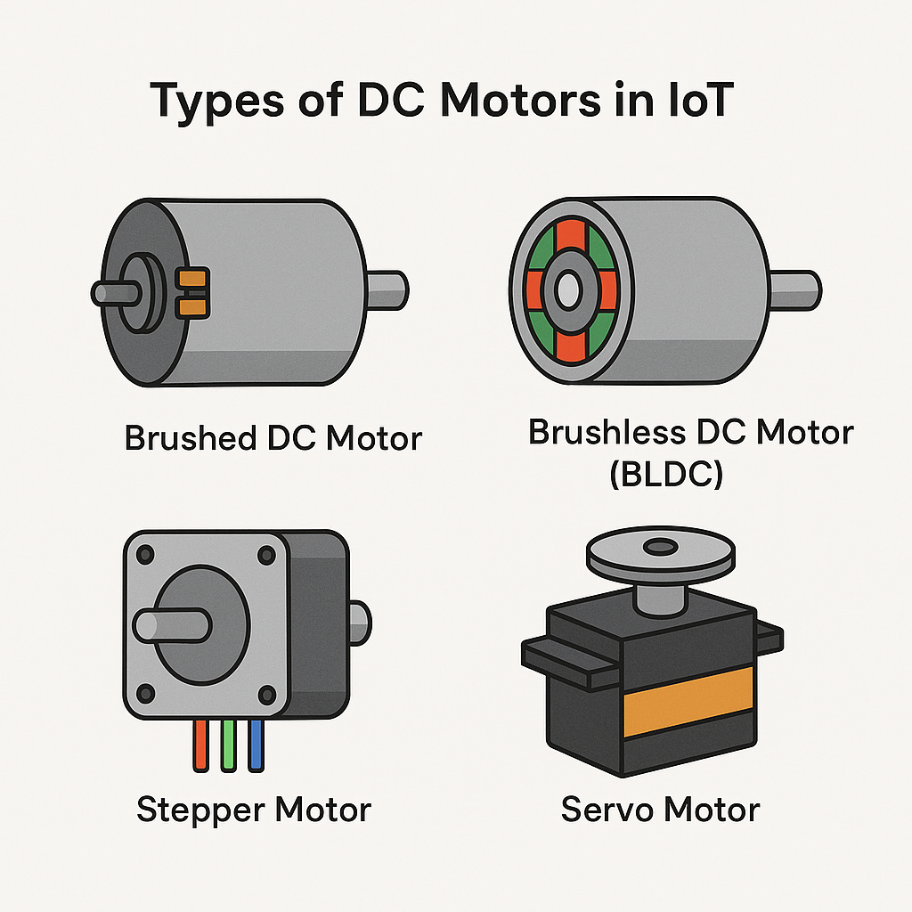

Servo Motors Interfacing and Programming

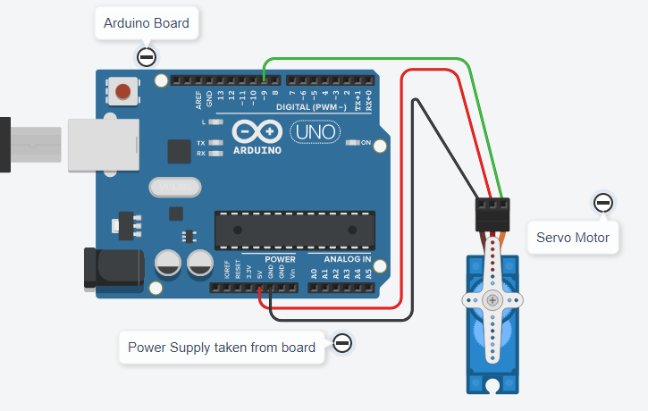
// sweep the servo from 0 to 180 degrees in steps of 1 degrees in clockwise and anticlock wise direction
#include <Servo.h>
int pos = 0;
Servo servo_9;u

void setup()
{ servo_9.attach(9); }

void loop()
{
// sweep the servo from 0 to 180 degrees in steps
// of 1 degrees
for (pos = 0; pos <= 180; pos += 1) {
// tell servo to go to position in variable 'pos'
servo_9.write(pos);
// wait 15 ms for servo to reach the position
delay(15); // Wait for 15 millisecond(s)
}
for (pos = 180; pos >= 0; pos -= 1) {
// tell servo to go to position in variable 'pos'
servo_9.write(pos);
// wait 15 ms for servo to reach the position
delay(15); // Wait for 15 millisecond(s)
}
}

Interfacing DC motors and Programming
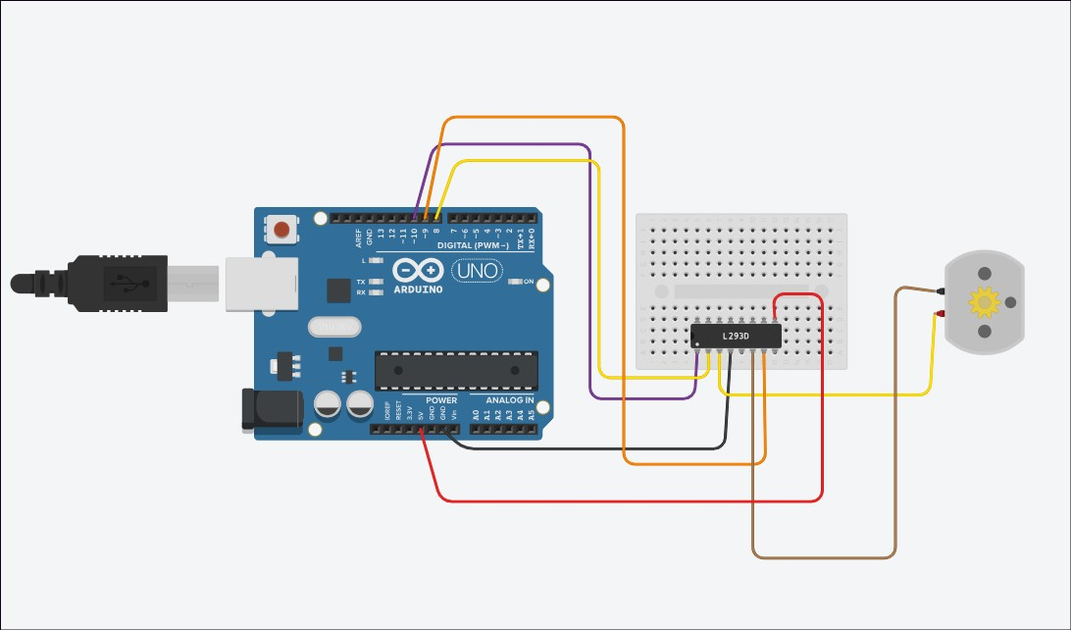

// Code to control DC motor C++ code
void setup()
{
pinMode(8, OUTPUT);
pinMode(9, OUTPUT);
pinMode(10, OUTPUT);
digitalWrite(10, HIGH); //enable motor driver

}

void loop()
{
//Stop the motro
digitalWrite(8, LOW);
digitalWrite(9, LOW);
// Run it in clockwise direction
digitalWrite(8, LOW);
digitalWrite(9, HIGH);
// Run it in Anti-clockwise direction
digitalWrite(8, HIGH);
digitalWrite(9, LOW);
}
L298N Motor Driver
The L298N is a popular, low-cost dual H-bridge motor driver module used in robotics and automation projects to control the speed and direction of DC and stepper motors. It's a versatile module, often used with microcontrollers like Arduino, and can handle relatively high current and voltage
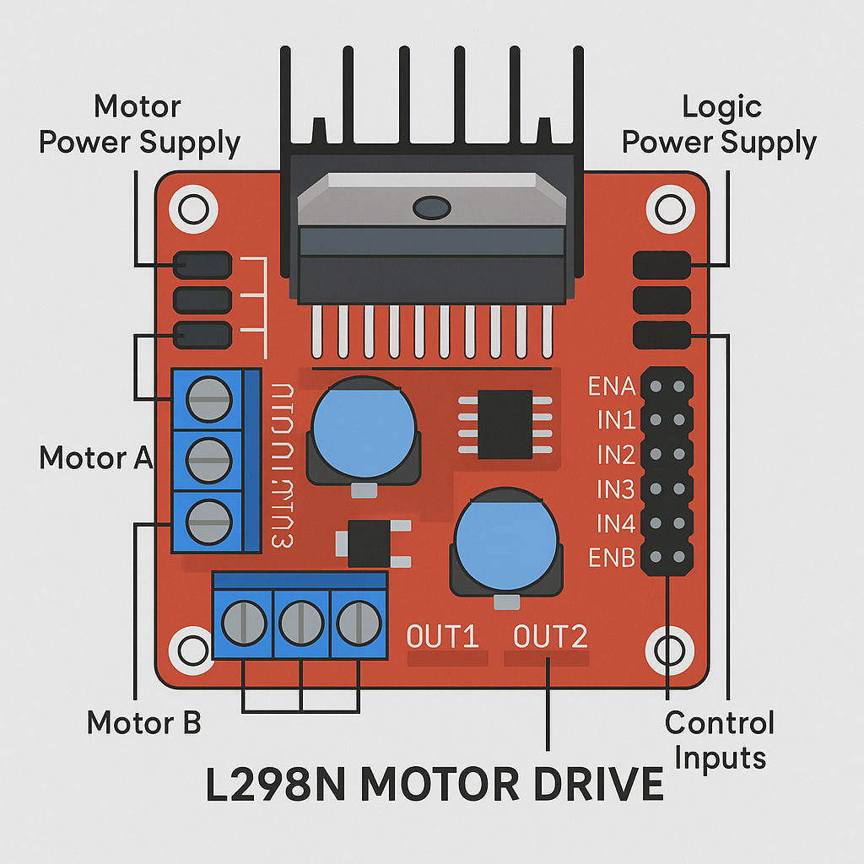
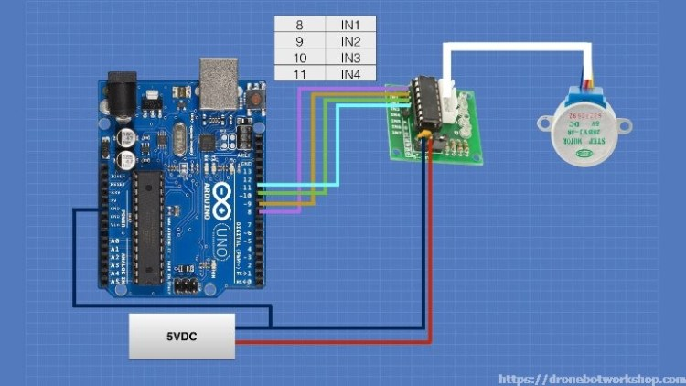
Stepper motor interfacing and Programming

void setup()
{
pinMode(8,OUTPUT);
pinMode(9,OUTPUT);
pinMode(10,OUTPUT);
pinMode(11,OUTPUT);
}

void loop()
{
digitalWrite(8,HIGH);
digitalWrite(9,LOW);
digitalWrite(10,LOW);
digitalWrite(11,LOW);
delay(10);
digitalWrite(8,LOW);
digitalWrite(9,HIGH);
digitalWrite(10,LOW);
digitalWrite(11,LOW);
delay(10);
digitalWrite(8,LOW);
digitalWrite(9,LOW);
digitalWrite(10,HIGH);
digitalWrite(11,LOW);
delay(10);
digitalWrite(8,LOW);
digitalWrite(9,LOW);
digitalWrite(10,LOW);
digitalWrite(11,HIGH);
delay(10);
}
Conclusions
Thus we interfaced and demonstrated DC motor, Servo motor and Stepper motor with Arduino. We studied that DC motors are useful for continuous speed control applications while servo motors are used for angular control such as robotics applications. Further Stepper motors are used to control for number of steps, such as printer stylus movement applications.

